WHITEHOUSE PRIMARY SCHOOL

Head Teacher: Mrs. S. Randle
Dunelm Road Elm Tree Farm Stockton-on-Tees TS19 OTS Tel/Fax 01642 678212

Dear Parents/Carers,
We apologise for the mix up - but World Book Day this year is on Thursday 1st March 2018, as opposed to the Friday, as previously informed.
We look forward to seeing the children dress up as their favourite character from a book and also challenge them to bring the book in that goes with their costume.
The children will be talking about their favourite stories and sharing some of their own stories with each other. More information can be found at: http://worldbookday.com/
We are also having an incentive for the children to bring in the book that their character is from. If they do this, they will be entered into a prize draw to win a book.

School Book Fair
We are having the school book fair in school from Monday 26th Feb – Friday 2nd March and it is open after school and during parent consultations (timings to follow on poster). The catalogues are given out with this letter and give an indication of the range of books on offer.
I look forward to seeing you at the next parent consultations.
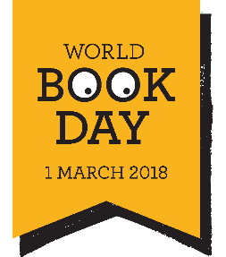
Yours sincerely,
Mrs S Randle,
Head Teacher.

