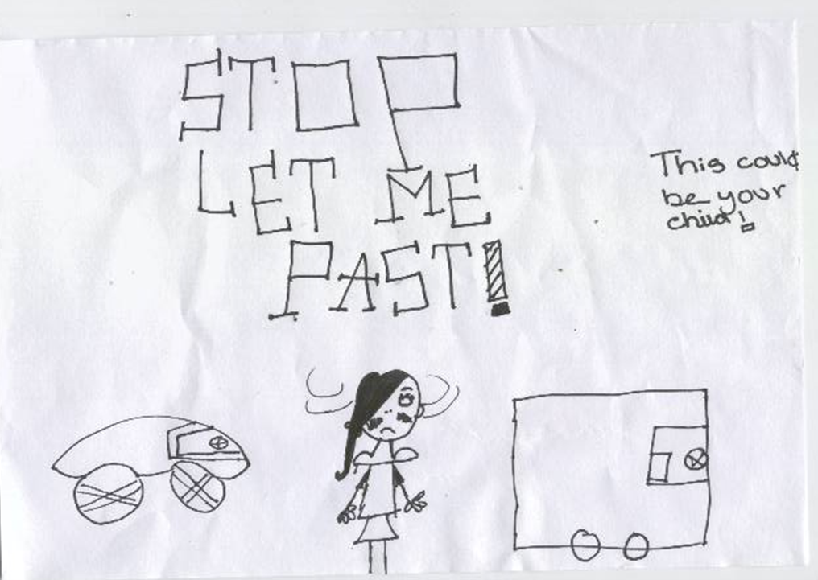

Park and Stride
The school has for years worked closely with the residents around the school, the police and enforcement officers to try to educate all site users about safety around the school. The majority of our parents understand and appreciate that as a community we should be considering the safety of all our children coming to school and park at either Sainsbury’s car park or behind the Elm Tree Shops and walk their children to school. Unfortunately we still have some parents who lack that consideration for others. If you are concerned about any dangerous driving around the area of the school then take the registration number and report the driver to the police.
At our Travel Plan Meeting on Tuesday the residents were explaining how difficult life is for them, with some sitting in their houses with their curtains closed due to the behaviour of some drivers.
One of the residents has written a letter giving their point of view;

Dear Carers,
Most of you are aware of the issues regarding parking at Whitehouse. We know about, and thank the many of you who do not add to these problems by walking, even some of the way. However, as we all know there is a co-hort of selfish, thoughtless and inconsiderate carers causing grave concern to all pedestrians, but particularly the children, by driving dangerously.
The residents appreciate some carers have difficulties due to work commitment’s, but some carers park around half an hour am and pm – ample time to walk from Elm Tree Shops and healthier. It is where some of you park that cause the problems. The volume of traffic driving along and parking on the pavement, especially with a large number of pedestrians, especially children makes the situation very dangerous. Then you leave insufficient room to get past, or doors open or block our drives. We get this am and pm every day of course we occasionally get frustrated. Some days there is absolute chaos around the School and other parents are now increasingly concerned not just residents. The police have been called to incidents by other parents, the school and the residents. That should never happen, but shows how bad the situation is, we love our homes, and our area, although your heavy cars are causing a great deal of damage to our pavements, this is costly to the council, and a tripping hazard to all but particularly the many elderly residents.
Please, think carefully and consider how you drive and park around school. We still beg you for the sake of all the children, not to park on the pavement or drive on it. Don’t spoil our area – do as you would be done by. How would you like it in your area? An accident will happen don’t let it be you that’s the cause.
A concerned resident

Thank you to the majority of parents/carers who walk or park and stride for the safety of everyone.

Parent Consultation Evenings
Just a reminder that it is parent consultation evenings next Monday and Tuesday 3.16-6pm. We look forward to seeing you there.

World Book Day
World Book day is Thursday 1st March not Friday as we initially published in the calendar.

Adverse Weather Conditions
We will always try our best to remain open (and warm) for the children to attend school. However if there are severe weather conditions which affect the school and a decision is taken to close the school, parent/carers will be notified through our school comms texting service, a notice on the school website, Stockton Borough Council website and publication on local radio stations.
Please remember to send the children in appropriately dressed for the cold weather.

Yours sincerely,

Mrs S Randle
Head Teacher

